ISCG7427 Assignment 1

## Deliverables for milestones 3 & 5

Team

CORP

ABDULLAH RAZA 1502734  
TARAN SINGH 1522652  
SHIRISH AMATYA 1513345

Contents

Deliverables for milestones 3 & 5 1

Project Vision 3

Team Vision Statement 3

Old vision 3

Team roles & team name 3

Resources/links 3

Team methodology 3

Sprints 3

Tools 4

Wireframes 4

Prioritized user stories 6

Product backlog 7

Sprint 0-1 8

Sprint 0-2 8

Sprint 0-3 8

Sprint 1-1 (May 20 – May 27) 8

Sprint plan (selected stories and tasks) 8

Sprint retrospective 10

Sprint 1-2 (May 27 – June 3) 11

Sprint plan (selected stories and tasks) 11

Sprint retrospective 11

# Project Vision

The backbone of a solid education is teaching children how to think. Providing students with an education that achieves this goal is done by diversifying how they are taught. This is done by attending various events, taking different types of classes, as well as physical and vocational training and all sorts of collaborative efforts. This means having several different agendas with inputs from a vast selection of people. In this day and age, doing all of this is necessary and takes up a big chunk of time and requires that parents, teachers and guardians need to plan when they will plan for those they are responsible for.

**For** parents, teachers and guardians **who** have to spend a lot of time managing, tracking and sharing agendas for multiple users, **the** Precog calendar **is a** web based application **that** allows multiple users to access, view and edit a multi-user calendar which can be used to upload files and plan for events.

## Team Vision Statement

To create a web application which enables the parents to track activities of their children as well as create a portal where they can communicate with the teachers as and when required.

## Old vision

The early years of a child are quite influential and malleable. The quality of education they receive during their primitive years has a significant impact on how their mind nurtures as they grow older. Thus, teaching children how to think creatively is foundation of a high-quality education system. One way of achieving this goal is engaging children and their parents in various activities and events.

While this idea seems great in theory, the parents are not able to keep up with the activities and events going on in their child’s school. Additionally, without a convenient medium, the parents are unable to communicate with the teachers to know how their child is progressing as well as how can they help.

In order to manage the information overload of events and activities as well as mitigate the communication barrier between teachers and parents, the Precog calendar is a web-based application that enables parents to keep track of various ongoing activities and events in their child’s school. It also acts as an easily accessible portal wherein the parents and teachers can communicate regarding the child’s progress.

# Team roles & team name

Team name - Corp

Scrum Master – Abdullah Raza  
Product Owner – Shirish Amatya  
Developer – Taran Singh

# Resources/links

GitHub repository: <https://github.com/tarantej/teamcorp_KG>

Heliohost link: <http://corp.heliohost.org/>

YouTrack project: <https://teamcorp.myjetbrains.com/youtrack/agiles/>

# Team methodology

## Sprints

Following the discoveries in our practice sprint (sprint 0) retrospective, our team decided to break down sprint 1 into two one-week sprints. We made this choice as it allowed us to shorten the feedback loop and iterate more. Both these sprints were treated the same way we would have treated the two-week sprint. Our plans, user stories and retrospectives for these have been included in this document.

## Tools

As we shared in our sprint 0 presentation, we tried each of the tools at our disposal and evaluated their advantages over the tools we were previously using. We discovered that most of the tools and services suggested in the coursework brought sufficient value and were worth adopting. We used the following tools and services in this project:

WhatsApp – Stand-ups, sprint retrospective and planning meetings and various communications

HelioHost – All hosting and database purposes

GitHub – Version control, code review, continuous integration and continuous delivery

YouTrack – Agile board, backlog, task estimation, task review, burndown chart, sprint planning and retrospective

Selenium – Testing & review of features developed

# Wireframes

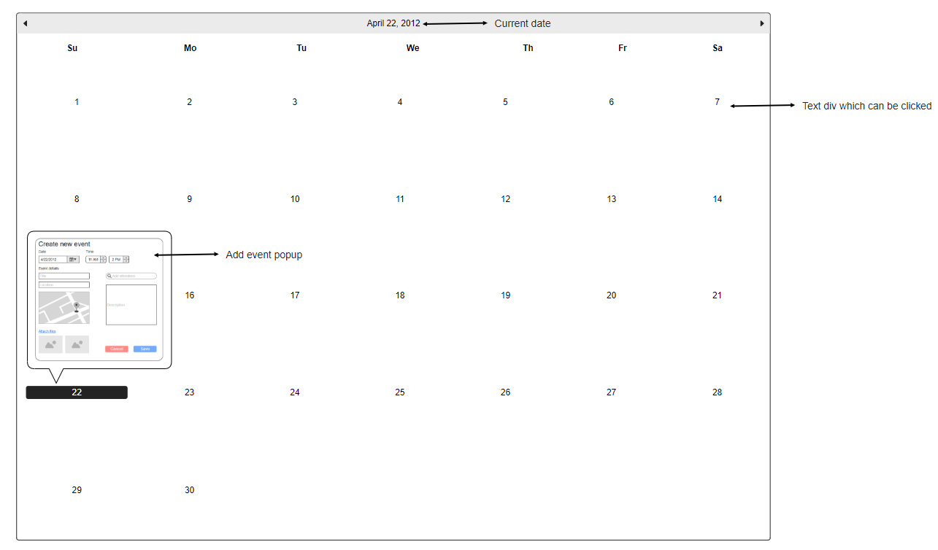

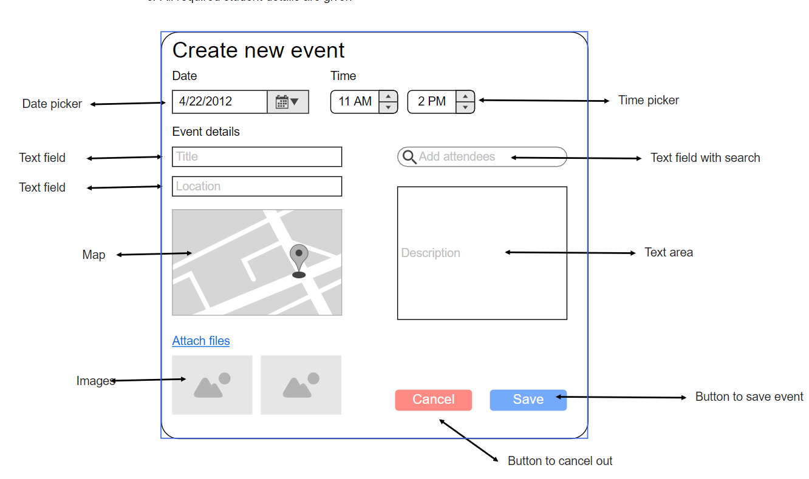

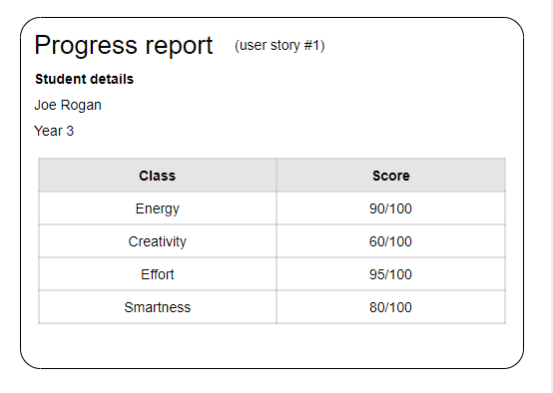

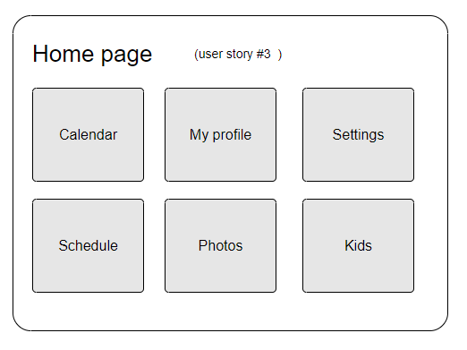

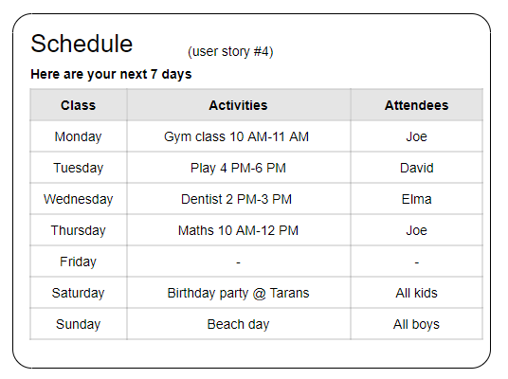

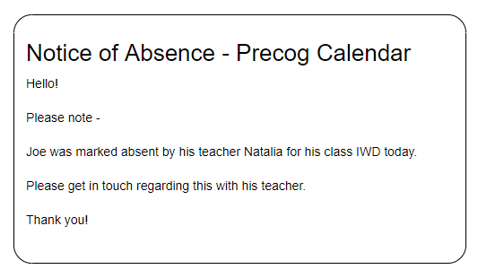

# Prioritized user stories

1. As an administrator, I want the details of parents and students to be stored in a database so that they are easy to manage access and control.
2. As a parent, I want to able to login to my account using a unique username so no one else can access my personal details.
3. As a parent, I want the registration page to be very minimal and simple so that their grandparents can understand it.
4. As a parent, I want to be able to set events for specific dates so I can track multiple activities easily.
5. As a parent, I want to be able to view all the dates of the calendar in a monthly view so I can see what is going to happen in the entire month using a single screen.
6. As a parent, I want to get to my profile in three clicks, so that it is nice and simple.
7. As a teacher, I want to register multiple children of the same parents in one registry so there is less data redundancy.
8. As a parent, I want to see the contact information of the staff members in charge of the event so that I can reach out to them with any queries or issues.
9. As an administrator, I want an administration dashboard so I can view and manage database items.
10. As a parent, I want to be get notified when my children are marked absent, so I am aware of them missing.
11. As a teacher, I want to create a messaging or chat option for the parents so that I can notify individual notices.
12. As a parent, I want to a get a link or a geographic map of the event addresses so that I can track my destination and time estimation.
13. As a parent, I want to get a reminder via email or text of the upcoming event so that I can prioritize to the event.
14. As a parent, I want to be notified of my child’s progress report so that I know what their strengths and weaknesses are.
15. As a parent, I want to view my children schedule and get notified if there has been a schedule change, so I can keep track on what’s going on.
16. As a parent, I want to be able to upload and attach files such as images and videos to the events so that I can save them for memories.
17. As a parent, I want to be able to color code events and items on the calendar, so they are easier to track.

# Product backlog

1. Storing data into a database:  
   As an administrator, I want the details of parents and students to be stored in a database so that they are easy to manage access and control.
2. Admin dashboard:  
   As an administrator, I want an administration dashboard so I can view and manage database items.
3. Creating a unique login system with a username and password:  
   As a parent, I want to able to login to my account using a unique username so no one else can access my personal details.
4. Create functionality to allow parents to add children:  
   As a teacher, I want to register multiple children of the same parents in one registry so there is less data redundancy.
5. Add monthly calendar view:

As a parent, I want to be able to view all the dates of the calendar in a monthly view so I can see what is going to happen in the entire month using a single screen.

1. Viewing contact information for security and safety measures:  
   As a parent, I want to see the contact information of the staff members in charge of the event so that I can reach out to them with any queries or issues.
2. Messaging:  
   As a teacher, I want to create a messaging or chat option for the parents so that I can notify individual notices.
3. Getting Addresses:  
   As a parent, I want to a get a link or a geographic map of the event addresses so that I can track my destination and time estimation.
4. Setting up a reminder:  
   As a parent, I want to get a reminder via email or text of the upcoming event so that I can prioritize to the event.
5. Attaching and uploading files:  
   As a parent, I want to be able to upload and attach media such as images and videos to the events so that I can save them for memories.
6. Colored labels for event tracing:  
   As a parent, I want to be able to add colored labels to events and items on the calendar, so they are easier to track.

# Sprint 0-1

Story points planned: 60  
Story points completed: 26

# Sprint 0-2

Story points planned: 50  
Story points completed: 20

# Sprint 0-3

Story points planned: 40  
Story points completed: 30

Planned: 150  
Done: 76

Details of each sprint including acceptance criteria, estimations, time logged and reviews are available on YouTrack.

# Sprint 1

## Sprint plan (selected stories and tasks)

For sprint 1, we’ve decided to commit and implement the following features by next sprint

1. User story: #1 As an administrator, I want the details of parents and students to be stored in a database so that they are easy to manage access and control.  
   Story points: 20  
   Prerequisites: CORP_KG-35 – Create a database, CORP_KG-38 – Link webpage to database  
   Tasks:   
   a) Enable login for admins  
   d) Allow admin to add events via editing the database

Acceptance criteria:

a) The database contains a new record every time a new user submits the registration form  
b) Users receive confirmation of their registration once the data has been added

1. User story: #4 As a parent, I want to be able to set events for specific dates so I can track multiple activities easily.  
   Story points: 15  
   Prerequisites: CORP_KG-55 – Create month layout  
   Tasks:  
   a) CORP_KG-66 – Create event object – simple JavaScript object that is used for creating events  
   b) CORP_KG-49 – Events functionality – create the functions required for creating a new event  
   c) CORP_KG-48 – Event dialog on click – when a day on the calendar is clicked, show a dialog with event item inputs

Acceptance criteria:  
a) Upon clicking a day on the calendar, a new event popup appears  
b) Once the user fills in the event data and clicks create, the calendar updates to reflect the changes and a new event is created

c) The event is saved to memory, so it persists once the user exits the application

1. User story: #7 As a teacher, I want to register multiple children of the same parents in one registry so there is less data redundancy.  
   Story points: 5   
   Prerequisites: CORP_KG-44 – Create parent object

Tasks:  
a) CORP_KG-61 – Create child object  
b) CORP_KG-60 – Create read only user object

Acceptance criteria:   
a) New users should be able to choose one of 3 roles (parent/guardian, relative, teacher) when registering  
b) Functions to create children for their calendars

1. User story: #8 As an administrator, I want to be able to have a profile page so that I can have a brief overview of the events published and add new events on the calendar  
   Story points: 5  
   Prerequisites: CORP_KG-35 – Create a database, CORP_KG-38 – Link webpage to database  
   Tasks:   
   a) Add additional fields for the users  
   b) show the additional fields on the profile  
   Acceptance criteria:  
   a) Database is accessible and all fields are visible
2. User story: #5 As a parent, I want to be able to view all the dates of the calendar in a monthly view so I can see what is going to happen in the entire month using a single screen.  
   Story points: 5 points

Prerequisites: Create month layout  
Tasks:  
a) Add tasks to monthly view which shows all events  
Acceptance criteria:  
a) All events are visible in a monthly view

1. User story: #6 As a parent, I want to get to my profile in three clicks, so that it is nice and simple.  
   Story points: 3 points  
   Prerequisites: Home page complete  
   Tasks:   
   a) Link profile page to homepage  
   Acceptance criteria:  
   a) User is able to access login page in one click from homepage

# Scrum meetings

